[Read More](https://www.bookswagon.com/promo-best-seller/best-seller/03AC998EBDC2)

**519403 results found**

Sort By:RelevancePrice - Low to HighPrice - High to LowDiscount

**34%**

**https://www.bookswagon.com/productimages/images200/781/9781861972781.jpg**

[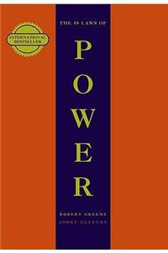](https://www.bookswagon.com/book/48-laws-power-robert-greene/9781861972781)

**The 48 Laws Of Power**Robert Greene

4.1 (10)

**₹659**

**30%**

[](https://www.bookswagon.com/book/my-first-library-editorial-wonder/9789387779266)

**My First Library**Wonder House Books Editorial

4.1 (8)

**₹524**

**38%**

[](https://www.bookswagon.com/book/harry-potter-box-set-jkrowling/9781408856772)

**Harry Potter Box Set: The Complete Collection (Children’s Paperback)**J.K.Rowling

4.3 (8)

**₹3,069**

**43%**

[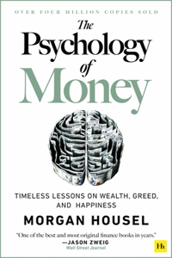](https://www.bookswagon.com/book/psychology-money-morgan-housel/9780857197689)

**The Psychology of Money**Morgan Housel

No Review Yet

**₹1,004**

[](https://www.bookswagon.com/book/satanic-verses-salman-rushdie/9780963270702)

**The Satanic Verses**Salman Rushdie

4.5 (6)

**₹1,350**

**10%**

[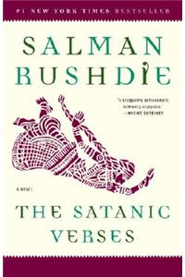](https://www.bookswagon.com/book/satanic-verses-salman-rushdie/9780812976717)

**Satanic Verses**Salman Rushdie

4.5 (6)

**₹1,454**

**23%**

[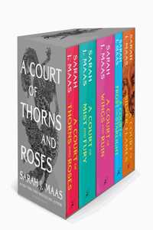](https://www.bookswagon.com/book/court-thorns-roses-paperback-box/9781526657077)

**A Court of Thorns and Roses Paperback Box Set (5 books)**Sarah J. Maas

5.0 (7)

**₹4,177**

**16%**

[](https://www.bookswagon.com/book/lego-gear-bots-editors-klutz/9781338603453)

**LEGO Gear Bots**

3.3 (8)

**₹1,827**

**39%**

[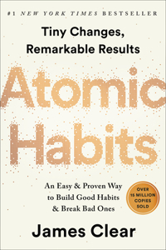](https://www.bookswagon.com/book/atomic-habits-james-clear/9780735211292)

**Atomic Habits**James Clear

No Review Yet

**₹1,433**

**29%**

[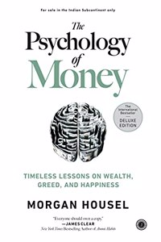](https://www.bookswagon.com/book/psychology-money-deluxe-edition-housel/9789390166930)

**THE PSYCHOLOGY OF MONEY (DELUXE EDITION)**Housel, Morgan

4.3 (7)

**₹425**

**28%**

[](https://www.bookswagon.com/book/dog-man-dav-pilkey/9781338896435)

**Dog Man 12: The Scarlet Shedder**Dav Pilkey

No Review Yet

**₹1,015**

**50%**

[](https://www.bookswagon.com/book/ikigai-francesc-miralles-hector-garcia/9780143130727)

**Ikigai**Francesc Miralles

No Review Yet

**₹1,194**

**20%**

[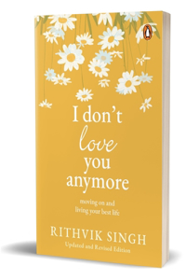](https://www.bookswagon.com/book/i-dont-love-you-anymore/9780143469131)

**I Don't Love You Anymore**Rithvik Singh

No Review Yet

**₹239**

**18%**

[](https://www.bookswagon.com/book/boxed-dog-man-dav-pilkey/9781338792164)

**Boxed - Dog Man: The Supa Buddies Mega Collection: From the Creator of Captain Underpants (Dog Man #1-10 Box Set)**Dav Pilkey

3.5 (4)

**₹9,268**

**29%**

[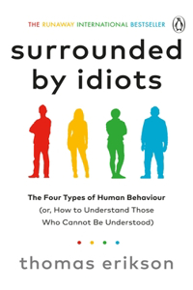](https://www.bookswagon.com/book/surrounded-by-idiots-thomas-erikson/9781785042188)

**Surrounded by Idiots**Thomas Erikson

3.6 (7)

**₹425**

**30%**

[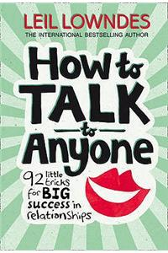](https://www.bookswagon.com/book/how-talk-anyone-leil-lowndes/9780722538074)

**How to Talk to Anyone**Leil Lowndes

4.9 (7)

**₹759**

**34%**

[](https://www.bookswagon.com/book/throne-glass-box-set-paperback/9781526650535)

**Throne of Glass Box Set (Paperback)**Sarah J. Maas

4.8 (10)

**₹3,597**

**43%**

[](https://www.bookswagon.com/book/millionaire-expat-andrew-hallam/9781119840107)

**Millionaire Expat**A Hallam

4.0 (5)

**₹1,172**

**37%**

[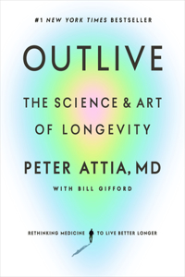](https://www.bookswagon.com/book/outlive-md-peter-attia-bill/9780593236598)

**Outlive**Bill Gifford

No Review Yet

**₹1,846**

**29%**

[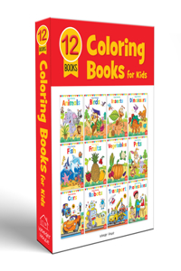](https://www.bookswagon.com/book/colouring-books-boxset-wonder-house/9789388369787)

**Coloring Books Boxset**Wonder House Books

4.5 (8)

**₹447**

**29%**

[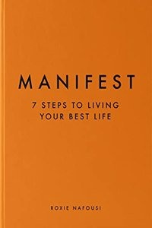](https://www.bookswagon.com/book/manifest-roxie-nafousi/9780241539590)

**Manifest**Nafousi, Roxie

3.8 (5)

**₹425**

**23%**

[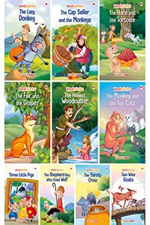](https://www.bookswagon.com/book/moral-story-kids-set-10/9789391129811)

**Moral Story Books for Kids (Set of 10 Books)**Maple Press

4.4 (7)

**₹270**

**30%**

[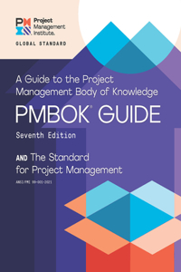](https://www.bookswagon.com/book/guide-body-knowledge-standard-project/9781628256642)

**Guide to the Project Management Body of Knowledge and the Standard for Project Management**Project Management Institute

4.7 (7)

**₹5,670**

**39%**

[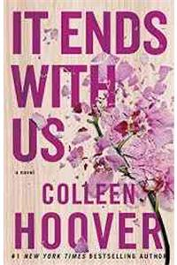](https://www.bookswagon.com/book/it-ends-us-colleen-hoover/9781501110368)

**It Ends with Us**Colleen Hoover

4.4 (12)

**₹304**

**33%**

[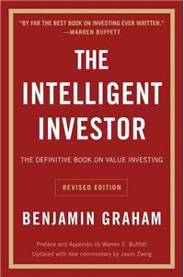](https://www.bookswagon.com/book/intelligent-investor-rev-ed-benjamin/9780060555665)

**Intelligent Investor REV Ed.**Benjamin Graham

4.5 (6)

**₹1,516**

[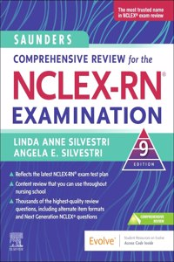](https://www.bookswagon.com/book/saunders-comprehensive-review-nclexrnr-examination/9780323795302)

**Saunders Comprehensive Review for the NCLEX-RN® Examination**Linda Anne Silvestri

4.6 (8)

**₹3,864**

**17%**

[](https://www.bookswagon.com/book/cant-hurt-me-david-goggins/9781544512273)

**Can't Hurt Me**David Goggins

4.4 (8)

**₹2,013**

**30%**

[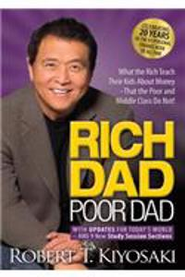](https://www.bookswagon.com/book/rich-poor-dad-t-robert/9781612680194)

**Rich Dad Poor Dad**Robert T Kiyosaki

No Review Yet

**₹549**

**29%**

[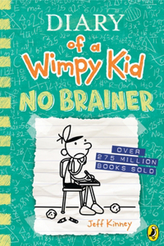](https://www.bookswagon.com/book/diary-wimpy-kid-jeff-kinney/9780241583135)

**Diary of a Wimpy Kid: No Brainer (Book 18)**Jeff Kinney

4.9 (7)

**₹425**

**31%**

[](https://www.bookswagon.com/book/nkjv-reference-bible-personal-size/9780785233596)

**NKJV, End-of-Verse Reference Bible, Personal Size Large Print, Leathersoft, Brown, Red Letter, Comfort Print**Thomas Nelson

5.0 (8)

**₹2,246**

**43%**

[](https://www.bookswagon.com/book/demon-slayer-complete-box-set/9781974725953)

**Demon Slayer: Kimetsu no Yaiba Complete Box Set**Koyoharu Gotouge

4.6 (5)

**₹12,150**

**21%**

[](https://www.bookswagon.com/book/numicon/9780198487272)

**Numicon: Box of 80 Numicon Shapes**

No Review Yet

**₹4,677**

**32%**

[](https://www.bookswagon.com/book/eat-drink-nap-soho-house/9781848094116)

**Eat, Drink, Nap**Soho House

4.9 (8)

**₹1,631**

**41%**

[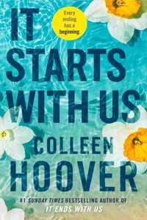](https://www.bookswagon.com/book/it-starts-us-colleen-hoover/9781398518179)

**It Starts with Us**Colleen Hoover

4.5 (2)

**₹412**

**39%**

[](https://www.bookswagon.com/book/creative-act-rick-rubin/9780593652886)

**The Creative Act**Rick Rubin

No Review Yet

**₹1,698**

**30%**

[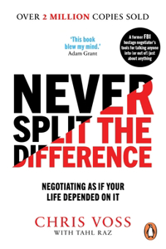](https://www.bookswagon.com/book/never-split-difference-tahl-raz/9781847941497)

**Never Split the Difference**Tahl Raz

4.7 (6)

**₹489**

**40%**

[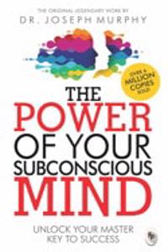](https://www.bookswagon.com/book/power-your-subconscious-mind-dr/9788172345662)

**Power of Your Subconscious Mind**Dr Joseph Murphy

4.2 (6)

**₹119**

**40%**

[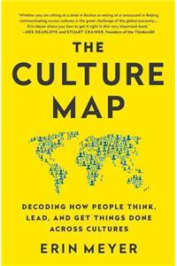](https://www.bookswagon.com/book/culture-map-erin-meyer/9781610392761)

**The Culture Map**Erin Meyer

4.8 (8)

**₹1,106**

[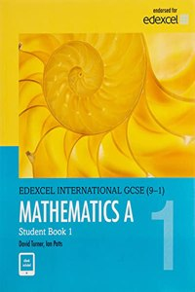](https://www.bookswagon.com/book/pearson-edexcel-international-gcse-91/9780435181444)

**Pearson Edexcel International GCSE (9-1) Mathematics A Student Book 1**D. A. Turner

4.6 (5)

**₹4,311**

**44%**

[](https://www.bookswagon.com/book/chanel-daniele-dani%C3%A8le-bott/9780500513606)

**Chanel**Daniele Bott

5.0 (6)

**₹2,430**

**33%**

[](https://www.bookswagon.com/book/vibes-good-life-vex-king/9781788171823)

**Good Vibes, Good Life**Vex King

4.3 (6)

**₹905**

**24%**

[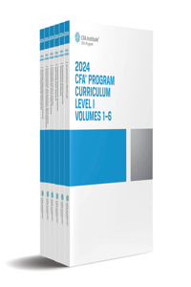](https://www.bookswagon.com/book/2024-cfa-program-curriculum-level/9781953337672)

**2024 Cfa Program Curriculum Level I Box Set**CFA INSTITUTE

No Review Yet

**₹20,136**

**14%**

[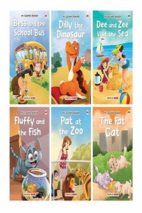](https://www.bookswagon.com/book/story-kids-second-reader-illustrated/9788119099399)

**Story Books for Kids - Second Reader (Illustrated) (Set of 6 Books) - Phonic stories - Bedtime Stories - 3 Years to 6 Years Old - Read Aloud to Infants, Toddlers**Maple Press

No Review Yet

**₹181**

**35%**

[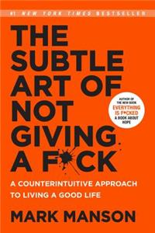](https://www.bookswagon.com/book/subtle-art-not-giving-a/9780062641540)

**The Subtle Art of Not Giving a F*ck**Mark Manson

4.6 (7)

**₹358**

**41%**

[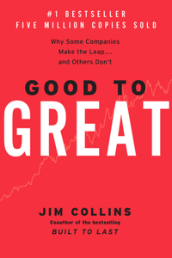](https://www.bookswagon.com/book/good-great-jim-collins/9780066620992)

**Good to Great**Jim Collins

4.5 (6)

**₹1,797**

**22%**

[](https://www.bookswagon.com/book/i-love-you-moon-back/9781589255517)

**I Love You to the Moon and Back**Amelia Hepworth

4.2 (5)

**₹543**

**35%**

[](https://www.bookswagon.com/book/good-girls-guide-murder-holly/9781405293181)

**A Good Girl's Guide to Murder**Holly Jackson

4.3 (4)

**₹324**

**29%**

[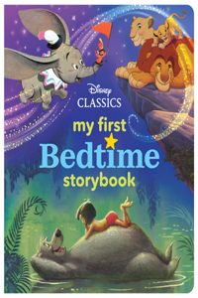](https://www.bookswagon.com/book/my-first-disney-classics-bedtime/9781368028103)

**My First Disney Classics Bedtime Storybook**

4.8 (8)

**₹679**

**27%**

[](https://www.bookswagon.com/book/first-aid-usmle-step-1/9781266077203)

**First Aid for the USMLE Step 1 2024**Vikas Bhushan

No Review Yet

**₹4,128**

**32%**

[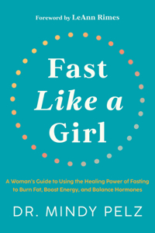](https://www.bookswagon.com/book/fast-like-a-girl-dr/9781401969929)

**Fast Like a Girl**Mindy Pelz

5.0 (7)

**₹1,359**

**30%**

[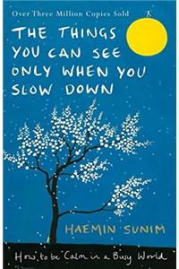](https://www.bookswagon.com/book/things-can-see-only-you/9780241340660)

**The Things You Can See Only When You Slow Down**Chi-Young Kim

5.0 (6)

**₹489**

**15%**

[](https://www.bookswagon.com/book/make-your-own-bath-bombs/9781338158809)

**Make Your Own Bath Bombs**

No Review Yet

**₹1,701**

**38%**

[](https://www.bookswagon.com/book/body-keeps-score-bessel-van/9780143127741)

**The Body Keeps the Score**Bessel Van Der Kolk

No Review Yet

**₹1,025**

**19%**

[](https://www.bookswagon.com/book/dog-man-dav-pilkey/9781338603347)

**Dog Man 1-6: The Supa Epic Collection: From the Creator of Captain Underpants**Dav Pilkey

5.0 (5)

**₹5,493**

**26%**

[](https://www.bookswagon.com/book/housemaid-freida-mcfadden/9781408728512)

**The Housemaid**Freida McFadden

No Review Yet

**₹802**

**32%**

[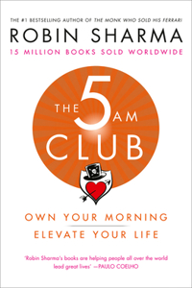](https://www.bookswagon.com/book/5-am-club-robin-sharma/9780008312831)

**The 5 AM Club**Robin Sharma

4.8 (6)

**₹1,254**

**29%**

[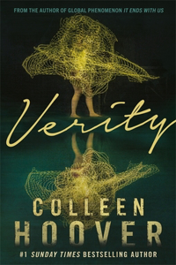](https://www.bookswagon.com/book/verity-colleen-hoover/9781408726600)

**Verity**Colleen Hoover

4.5 (8)

**₹283**

**30%**

[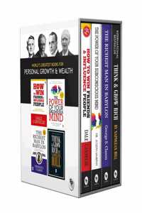](https://www.bookswagon.com/book/worlds-greatest-personal-growth-wealth/9789389432015)

**World’s Greatest Books For Personal Growth & Wealth (Set of 4 Books) : Perfect Motivational Gift Set**Dale Carnegie, Napoleon Hill, Dr. Joseph Murphy & George S. Clason

4.6 (15)

**₹489**

**33%**

[](https://www.bookswagon.com/book/roald-dahl-collection-16-books/9780241377291)

**Roald Dahl Collection 16 Books Box Set**Roald Dahl

4.5 (4)

**₹3,349**

**22%**

[](https://www.bookswagon.com/book/so-good-emily-english/9781399620055)

**So Good**Emily English

No Review Yet

**₹2,036**

**4%**

[](https://www.bookswagon.com/book/100m-leads-alex-hormozi/9781737475767)

**$100M Leads**Alex Hormozi

No Review Yet

**₹2,506**

**33%**

[](https://www.bookswagon.com/book/essential-guide-dubai-real-estate/9781032033563)

**Essential Guide to the Dubai Real Estate Market**Michael Waters

No Review Yet

**₹3,439**

**31%**

[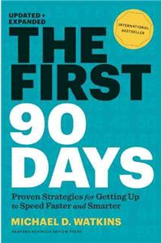](https://www.bookswagon.com/book/first-90-days-updated-expanded/9781422188613)

**The First 90 Days, Updated and Expanded**Michael Watkins

4.3 (6)

**₹827**

**30%**

[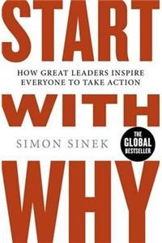](https://www.bookswagon.com/book/start-why-simon-sinek/9780241958223)

**Start With Why**Simon Sinek

5.0 (4)

**₹489**

**29%**

[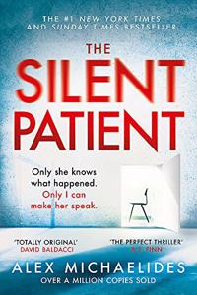](https://www.bookswagon.com/book/silent-patient-alex-michaelides/9781409181637)

**The Silent Patient**Alex Michaelides

4.0 (4)

**₹283**

**38%**

[](https://www.bookswagon.com/book/live-beautiful-athena-calderone/9781419742804)

**Live Beautiful**Athena Calderone

5.0 (7)

**₹2,433**

**30%**

[](https://www.bookswagon.com/book/art-war-deluxe-hardbound-edition/9789388369695)

**Art of War (Deluxe Hardbound Edition)**Sun Tzu

4.7 (6)

**₹1,035**

**35%**

[](https://www.bookswagon.com/book/good-girls-guide-murder-box/9780008534967)

**Holly Jackson box set**Holly Jackson

4.8 (8)

**₹909**

**38%**

[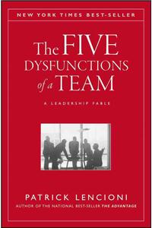](https://www.bookswagon.com/book/five-dysfunctions-a-team-m/9780787960759)

**Five Dysfunctions of a Team**Patrick Lencioni

5.0 (5)

**₹1,456**

**16%**

[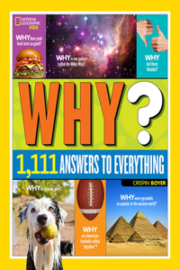](https://www.bookswagon.com/book/national-geographic-kids-why-crispin/9781426320965)

**National Geographic Kids Why?**Crispin Boyer

4.6 (5)

**₹1,462**

**42%**

[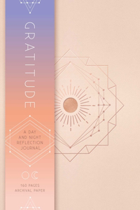](https://www.bookswagon.com/book/gratitude-insight-editions/9781683835509)

**Gratitude**Insight Editions

4.9 (8)

**₹811**

[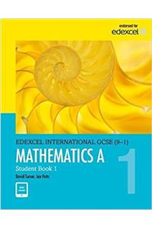](https://www.bookswagon.com/book/pearson-edexcel-international-gcse-91/9780435183059)

**Pearson Edexcel International GCSE (9-1) Mathematics A Student Book 2**D. A. Turner

4.5 (2)

**₹4,301**

[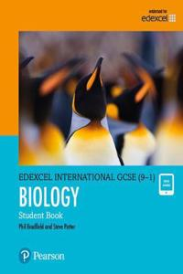](https://www.bookswagon.com/book/pearson-edexcel-international-gcse-91/9780435185084)

**Pearson Edexcel International GCSE (9-1) Biology Student Book**Steve Potter

4.6 (7)

**₹3,097**

**28%**

[](https://www.bookswagon.com/book/glucose-goddess-method-jessie-inchauspe/9781915780003)

**The Glucose Goddess Method**Jessie Inchauspe

4.8 (8)

**₹1,860**

**23%**

[](https://www.bookswagon.com/book/destinations-a-lifetime-national-geographic/9781426215643)

**Destinations of a Lifetime**National Geographic

4.7 (7)

**₹3,342**

**33%**

[](https://www.bookswagon.com/book/caraval-paperback-boxed-set-stephanie/9781250259530)

**Caraval Paperback Boxed Set**Stephanie Garber

5.0 (6)

**₹2,447**

**20%**

[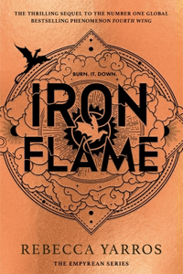](https://www.bookswagon.com/book/untitled-rebecca-yarros-2-rebecca/9780349437033)

**Iron Flame**Rebecca Yarros

4.8 (4)

**₹1,475**

**28%**

[](https://www.bookswagon.com/book/art-home-shea-mcgee/9780785236832)

**The Art of Home**Shea McGee

No Review Yet

**₹2,506**

**32%**

[](https://www.bookswagon.com/book/powerless-roberts-lauren/9781398529489)

**Powerless**Lauren Roberts

4.5 (6)

**₹407**

**28%**

[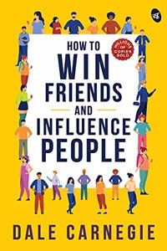](https://www.bookswagon.com/book/how-win-friendsand-influence-people/9788194790891)

**How to Win Friends and Influence People**Carnegie, Dale

4.0 (6)

**₹180**

**35%**

[](https://www.bookswagon.com/book/secrets-divine-love--helwa/9781734231205)

**Secrets of Divine Love**A Helwa

4.8 (5)

**₹1,411**

**22%**

[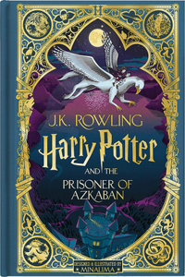](https://www.bookswagon.com/book/prisoner-azkaban-harry-potter-book/9781338815283)

**Harry Potter and the Prisoner of Azkaban (Harry Potter, Book 3) (Minalima Edition)**J K ROWLING

No Review Yet

**₹2,714**

**32%**

[](https://www.bookswagon.com/book/twisted-love-ana-huang/9780349434278)

**Twisted Love**Ana Huang

4.3 (8)

**₹407**

[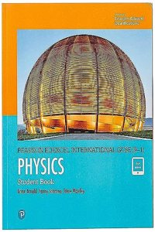](https://www.bookswagon.com/book/pearson-edexcel-international-gcse-91/9780435185275)

**Pearson Edexcel International GCSE (9-1) Physics Student Book**Penny Johnson

4.3 (6)

**₹4,180**

**33%**

[](https://www.bookswagon.com/book/untethered-soul-a-singer-a/9781572245372)

**The Untethered Soul**Michael A. Singer

4.3 (8)

**₹1,162**

**23%**

[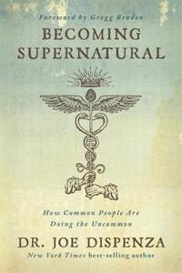](https://www.bookswagon.com/book/becoming-supernatural-dr-joe-dr/9781781808313)

**Becoming Supernatural**Dr. Joe Dispenza

4.7 (6)

**₹1,336**

**30%**

[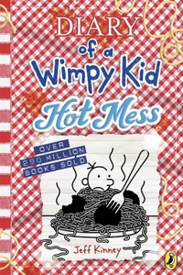](https://www.bookswagon.com/book/untitled-332595-jeff-kinney-author/9780241583166)

**Diary of a Wimpy Kid: Hot Mess (Book 19)**Jeff Kinney

No Review Yet

**₹455**

**34%**

[](https://www.bookswagon.com/book/glucose-revolution-inchauspe-jessie/9781780725239)

**Glucose Revolution**Jessie Inchauspe

5.0 (3)

**₹527**

**17%**

[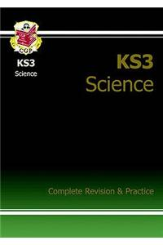](https://www.bookswagon.com/book/ks3-science-complete-revision-practice/9781841463858)

**KS3 Science Complete Revision & Practice – Higher (includes Online Edition, Videos & Quizzes)**Au

4.7 (7)

**₹1,143**

**31%**

[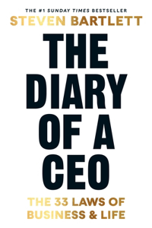](https://www.bookswagon.com/book/diary-a-ceo-steven-bartlett/9781529146516)

**The Diary of a CEO**Steven Bartlett

4.9 (8)

**₹689**

**41%**

[](https://www.bookswagon.com/book/housemaids-secret-freida-mcfadden/9780349132600)

**The Housemaid's Secret**Freida McFadden

No Review Yet

**₹693**

**28%**

[](https://www.bookswagon.com/book/interior-design-handbook-frida-ramstedt/9780593139318)

**Interior Design Handbook**Frida Ramstedt

5.0 (5)

**₹1,879**

**31%**

[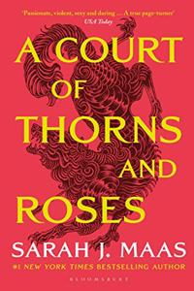](https://www.bookswagon.com/book/court-thorns-roses-sarah-j/9781526605399)

**A Court of Thorns and Roses**Sarah J. Maas

4.0 (3)

**₹673**

**27%**

[](https://www.bookswagon.com/book/dog-man-dav-pilkey/9781338801910)

**Dog Man 11: Twenty Thousand Fleas Under the Sea**Dav Pilkey

4.9 (9)

**₹1,029**

**31%**

[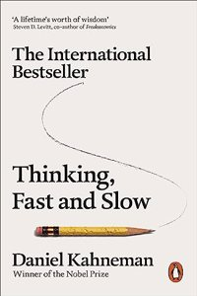](https://www.bookswagon.com/book/thinking-fast-slow-daniel-kahneman/9780141033570)

**Thinking, Fast and Slow**Daniel Kahneman

4.2 (6)

**₹551**

**40%**

[](https://www.bookswagon.com/book/autobiography-a-yogi-yogananda-paramahamsa/9788189535513)

**Autobiography of a Yogi**Yogananda Paramahamsa

4.1 (7)

**₹114**

**31%**

[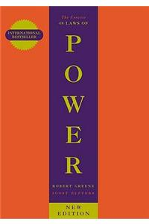](https://www.bookswagon.com/book/concise-48-laws-power-robert/9781861974044)

**The Concise 48 Laws Of Power**Robert Greene

4.6 (9)

**₹413**

**40%**

[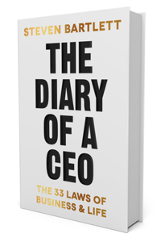](https://www.bookswagon.com/book/diary-a-ceo-steven-bartlett/9780593715833)

**Diary of a CEO**Steven Bartlett

No Review Yet

**₹1,566**

**21%**

[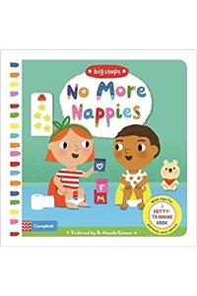](https://www.bookswagon.com/book/no-more-nappies-au-illustrator/9781509836314)

**No More Nappies**Au

4.3 (6)

**₹600**

**39%**

[](https://www.bookswagon.com/book/anxious-generation-jonathan-haidt/9780593655030)

**Anxious Generation**Jonathan Haidt

No Review Yet

**₹1,592**

**20%**

[](https://www.bookswagon.com/book/quran-m-a-s-haleem/9780199535958)

**Qur'an**M A S Abdel Haleem

5.0 (6)

**₹496**

**30%**

[](https://www.bookswagon.com/book/tom-ford-graydon-carter-anna/9780847826698)

**Tom Ford**Graydon Carter

5.0 (6)

**₹7,595**

[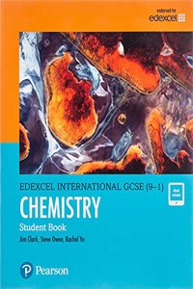](https://www.bookswagon.com/book/pearson-edexcel-international-gcse-91/9780435185169)

**Pearson Edexcel International GCSE (9-1) Chemistry Student Book**Rachel Yu

4.4 (7)

**₹4,192**

**47%**

[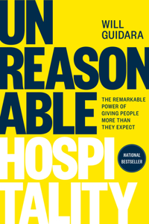](https://www.bookswagon.com/book/unreasonable-hospitality--guidara/9780593418574)

**Unreasonable Hospitality**Will Guidara

4.9 (7)

**₹1,337**

**39%**

[](https://www.bookswagon.com/book/made-living-amber-lewis-cat/9781984823915)

**Made for Living**Amber Lewis

4.1 (7)

**₹1,341**

**44%**

[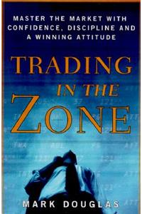](https://www.bookswagon.com/book/trading-in-zone-mark-douglas/9780735201446)

**Trading in the Zone**Mark Douglas

4.8 (4)

**₹3,167**

**41%**

[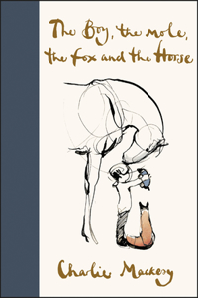](https://www.bookswagon.com/book/boy-mole-fox-horse-charlie/9780062976581)

**Boy, the Mole, the Fox and the Horse**Charlie Mackesy

No Review Yet

**₹1,181**

**32%**

[](https://www.bookswagon.com/book/best-childrens-classics-antoine-de/9789389432008)

**Best of Children's Classics (Set of 5 Books)**Antoine de Saint-Exupéry, J.M. Barrie, Frances Hodgson Burnett & L. Frank Baum

4.5 (6)

**₹679**

**26%**

[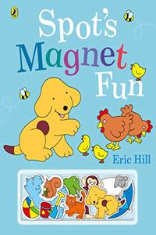](https://www.bookswagon.com/book/spots-magnet-fun-hill-eric/9780241509708)

**Spot's Magnet Fun**Eric Hill

5.0 (3)

**₹333**

**36%**

[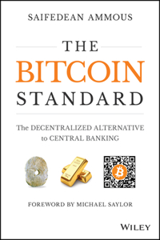](https://www.bookswagon.com/book/bitcoin-standard-s-ammous-saifedean/9781119473862)

**The Bitcoin Standard**Saifedean Ammous

4.3 (6)

**₹1,733**

**37%**

[](https://www.bookswagon.com/book/this-home-chris-warnes-natalie/9781743793459)

**This Is Home**Chris Warnes

4.7 (7)

**₹2,410**

**29%**

[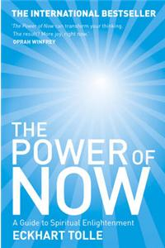](https://www.bookswagon.com/book/power-now-eckhart-tolle/9780340733509)

**The Power of Now**Eckhart Tolle

5.0 (5)

**₹1,001**

**24%**

[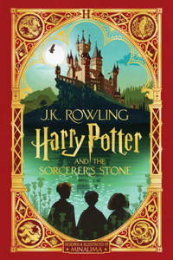](https://www.bookswagon.com/book/sorcerers-stone-harry-potter-book/9781338596700)

**Harry Potter and the Sorcerer's Stone (Harry Potter, Book 1) (Minalima Edition)**J K ROWLING

4.4 (9)

**₹2,513**

**27%**

[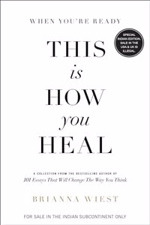](https://www.bookswagon.com/book/youre-ready-this-you-heal/9789355435538)

**When You're Ready, This is How You Heal (English)**Brianna Wiest

No Review Yet

**₹364**

**34%**

[](https://www.bookswagon.com/book/see-touch-feel-roger-priddy/9780312527594)

**See, Touch, Feel**Roger Priddy

4.5 (6)

**₹561**

**34%**

[](https://www.bookswagon.com/book/harry-potter-philosophers-stone-jk/9781408855652)

**Harry Potter and the Philosopher's Stone**J. K. Rowling

4.8 (6)

**₹395**

**41%**

[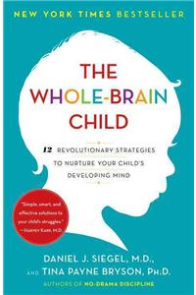](https://www.bookswagon.com/book/wholebrain-child-tina-payne-bryson/9780553386691)

**Whole-Brain Child**Tina Payne Bryson

4.6 (5)

**₹975**

**40%**

[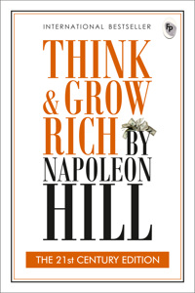](https://www.bookswagon.com/book/think-grow-rich-napoleon-hill/9789389931525)

**Think & Grow Rich: THE 21st CENTURY EDITION**Napoleon Hill

4.9 (7)

**₹119**

**24%**

[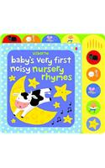](https://www.bookswagon.com/book/babys-very-first-noisy-nursery/9781409549710)

**Baby's Very First Noisy Nursery Rhymes**Stella Baggott

3.2 (6)

**₹824**

**37%**

[](https://www.bookswagon.com/book/wonderful-things-you-be-emily/9780385376716)

**The Wonderful Things You Will Be**Emily Martin

4.0 (8)

**₹987**

**32%**

[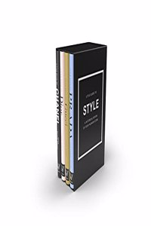](https://www.bookswagon.com/book/little-guides-style-emma-baxterwright/9781787396791)

**Little Guides to Style**Emma Baxter-Wright

5.0 (5)

**₹3,845**

**27%**

[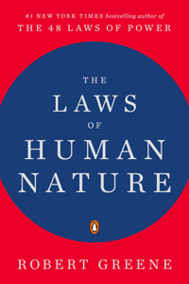](https://www.bookswagon.com/book/laws-human-nature-robert-greene/9780143111375)

**The Laws of Human Nature**Robert Greene

No Review Yet

**₹1,588**

**28%**

[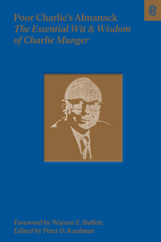](https://www.bookswagon.com/book/poor-charlies-almanack-warren-buffett/9781953953230)

**Poor Charlie's Almanack**Charles T. Munger

5.0 (7)

**₹1,799**

**30%**

[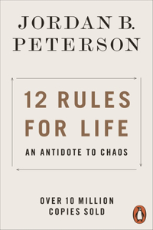](https://www.bookswagon.com/book/12-rules-life-jordan-b/9780141988511)

**12 Rules for Life**Jordan B. Peterson

4.3 (10)

**₹489**

**35%**

[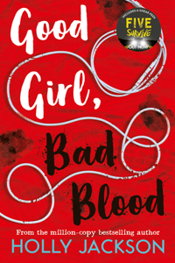](https://www.bookswagon.com/book/good-girl-bad-blood-holly/9781405297752)

**Good Girl, Bad Blood**Holly Jackson

4.9 (7)

**₹324**

**21%**

[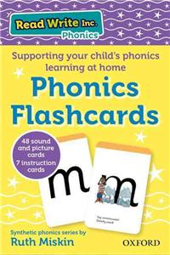](https://www.bookswagon.com/book/read-write-inc-home-tim/9780198386711)

**Read Write Inc. Home: Phonics Flashcards**Tim Archbold

4.9 (7)

**₹650**

[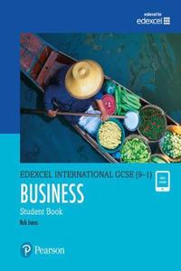](https://www.bookswagon.com/book/pearson-edexcel-international-gcse-91/9780435188634)

**Pearson Edexcel International GCSE (9-1) Business Student Book**Rob Jones

3.5 (2)

**₹3,097**

**20%**

[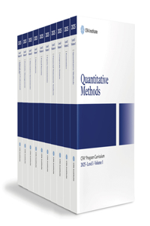](https://www.bookswagon.com/book/2025-cfa-program-curriculum-level/9781961409088)

**2025 Cfa Program Curriculum Level I Box Set**CFA INSTITUTE

No Review Yet

**₹17,397**

[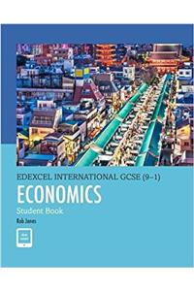](https://www.bookswagon.com/book/pearson-edexcel-international-gcse-91/9780435188641)

**Pearson Edexcel International GCSE (9-1) Economics Student Book**Rob Jones

4.0 (1)

**₹3,097**

**27%**

[](https://www.bookswagon.com/book/medical-medium-cleanse-heal-anthony/9781401958459)

**Medical Medium Cleanse to Heal**Anthony William

5.0 (5)

**₹2,335**

**42%**

[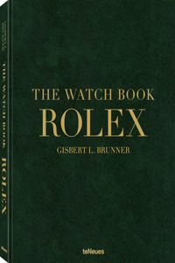](https://www.bookswagon.com/book/watch-book-rolex-l-gisbert/9783961715039)

**The Watch Book Rolex: 3rd updated and extended edition**Gisbert L. Brunner

No Review Yet

**₹5,551**

**26%**

[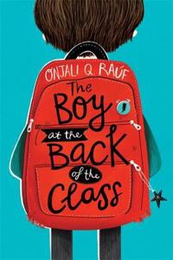](https://www.bookswagon.com/book/boy-at-back-class-pippa/9781510105010)

**The Boy At the Back of the Class**Onjali Rauf

5.0 (6)

**₹642**

**17%**

[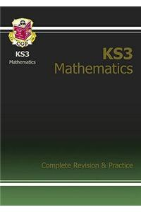](https://www.bookswagon.com/book/ks3-maths-complete-revision-practice/9781841463834)

**KS3 Maths Complete Revision & Practice – Higher (includes Online Edition, Videos & Quizzes)**Au

4.3 (6)

**₹1,143**

**24%**

[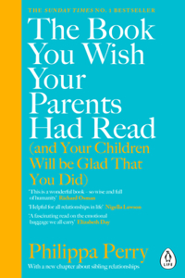](https://www.bookswagon.com/book/book-wish-parents-had-read/9780241251027)

**The Book You Wish Your Parents Had Read (and Your Children Will Be Glad That You Did)**Philippa Perry

4.2 (6)

**₹455**

**44%**

[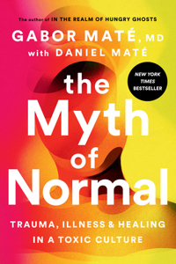](https://www.bookswagon.com/book/myth-normal-md-gabor-mate/9780593083888)

**Myth of Normal**Gabor Maté

5.0 (7)

**₹1,559**

**32%**

[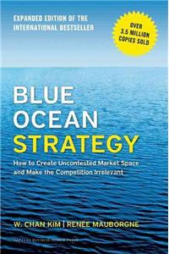](https://www.bookswagon.com/book/blue-ocean-strategy-expanded-edition/9781625274496)

**Blue Ocean Strategy, Expanded Edition**W Chan Kim

4.8 (5)

**₹1,019**

**38%**

[](https://www.bookswagon.com/book/chanel-catwalk-patrick-mauries-adelia/9780500023440)

**Chanel Catwalk**Patrick Mauries

5.0 (7)

**₹4,170**

**44%**

[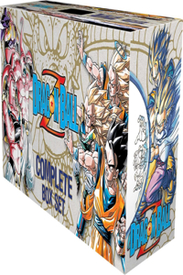](https://www.bookswagon.com/book/dragon-ball-z-complete-box/9781974708727)

**Dragon Ball Z Complete Box Set**Akira Toriyama

5.0 (6)

**₹13,642**

**23%**

[](https://www.bookswagon.com/book/paw-patrol-pocket-library-paw/9780755502721)

**Paw Patrol Pocket Library**Paw Patrol

4.7 (9)

**₹501**

**42%**

[](https://www.bookswagon.com/book/untitled-nonfiction-pp-walter-isaacson/9781398527492)

**Elon Musk**Walter Isaacson

4.8 (9)

**₹869**

**28%**

[](https://www.bookswagon.com/book/diary-wimpy-kid-jeff-kinney/9780241583081)

**Diary of a Wimpy Kid: Diper Overlode (Book 17)**Jeff Kinney

No Review Yet

**₹396**

**32%**

[](https://www.bookswagon.com/book/world-atlas-coffee-james-hoffmann/9781784724290)

**The World Atlas of Coffee**James Hoffmann

4.6 (7)

**₹1,427**

**14%**

[](https://www.bookswagon.com/book/alchemist-paulo-coelho/9780007155668)

**The Alchemist**Paulo Coelho

4.6 (7)

**₹653**

**40%**

[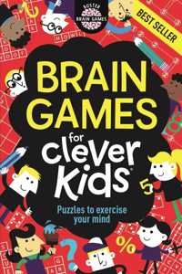](https://www.bookswagon.com/book/brain-games-clever-kids-chris/9781780552491)

**Brain Games For Clever Kids®**Gareth Moore

4.5 (8)

**₹119**

**40%**

[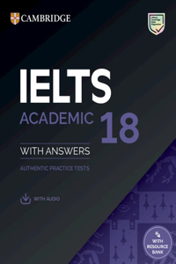](https://www.bookswagon.com/book/ielts-18-academic-students-book/9781009275187)

**Ielts 18 Academic Student's Book with Answers with Audio with Resource Bank**

No Review Yet

**₹2,389**

**36%**

[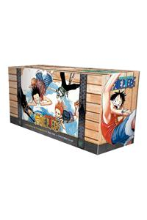](https://www.bookswagon.com/book/one-piece-box-set-2/9781421576060)

**One Piece Box Set 2: Skypiea and Water Seven**Eiichiro Oda

5.0 (8)

**₹10,239**

**31%**

[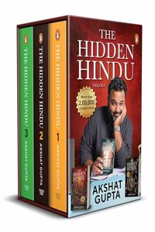](https://www.bookswagon.com/book/hidden-hindu-trilogy-gupta-akshat/9780143467359)

**The Hidden Hindu Trilogy**Gupta, Akshat

No Review Yet

**₹551**

**21%**

[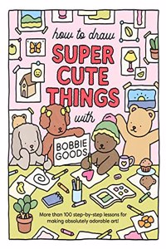](https://www.bookswagon.com/book/how-draw-super-cute-things/9780760385029)

**How to Draw Super Cute Things with Bobbie Goods**Bobbie Goods

No Review Yet

**₹1,375**

**40%**

[](https://www.bookswagon.com/book/attached-amir-levine-rachel-heller/9781529032178)

**Attached**Amir Levine

4.4 (7)

**₹390**

**25%**

[](https://www.bookswagon.com/book/minimalista-shira-gill/9781984859273)

**Minimalista**Shira Gill

No Review Yet

**₹1,958**

**30%**

[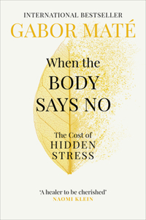](https://www.bookswagon.com/book/body-says-no-dr-gabor/9781785042225)

**When the Body Says No**Gabor Mate

4.8 (5)

**₹489**

**39%**

[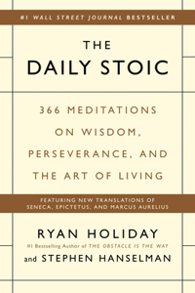](https://www.bookswagon.com/book/daily-stoic-ryan-holiday-stephen/9780735211735)

**Daily Stoic**Ryan Holiday

No Review Yet

**₹1,539**

**32%**

[](https://www.bookswagon.com/book/man-his-watch-matt-matthew/9781579657147)

**A Man & His Watch**Matt Hranek

4.8 (6)

**₹2,662**

**22%**

[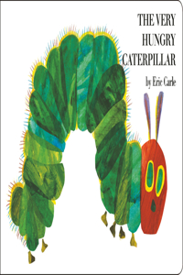](https://www.bookswagon.com/book/very-hungry-caterpillar-eric-carle/9780399226908)

**Very Hungry Caterpillar**Eric Carle

4.9 (7)

**₹429**

**31%**

[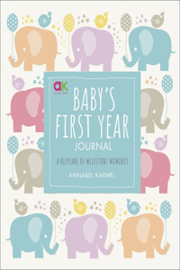](https://www.bookswagon.com/book/babys-first-year-journal-annabel/9780241365601)

**Baby's First Year Journal**Annabel Karmel

4.3 (9)

**₹620**

**16%**

[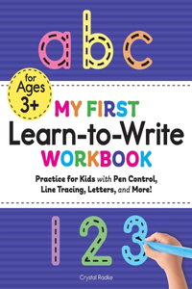](https://www.bookswagon.com/book/my-first-learntowrite-workbook-crystal/9781641526272)

Quick View**My First Learn-To-Write Workbook**Crystal Radke

5.0 (11)

**₹643**

**30%**

[](https://www.bookswagon.com/book/amulet-19-box-set-kazu/9781339043456)

**Amulet Box set 1-9 Graphix**Kazu Kibuishi

No Review Yet

**₹7,512**

**29%**

[](https://www.bookswagon.com/book/high-performance-planner-brendon-burchard/9781401957230)

**The High Performance Planner**Brendon Burchard

4.0 (8)

**₹1,853**

**35%**

[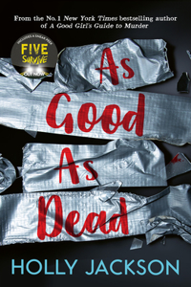](https://www.bookswagon.com/book/good-as-dead-jackson-holly/9781405298605)

**As Good As Dead**Holly Jackson

4.4 (8)

**₹324**

**40%**

[](https://www.bookswagon.com/book/berserk-deluxe-volume-1-jason/9781506711980)

**Berserk Deluxe Volume 1**Jason DeAngelis

4.9 (8)

**₹2,399**